Regression
regression refers to a statistical method used to understand the relationship between a dependent variable and one or more independent variables.
It essentially helps predict a variable's value based on the values of other related variables.
Dependent Variable:
The variable being predicted or whose value is being explained (often denoted as 'Y').
Independent Variable(s):
The variables used to predict or explain the dependent variable (often denoted as 'X').
Linear Regression
A simple type of regression where the relationship between variables is assumed to be linear. It can be simple (one independent variable) or multiple (multiple independent variables).
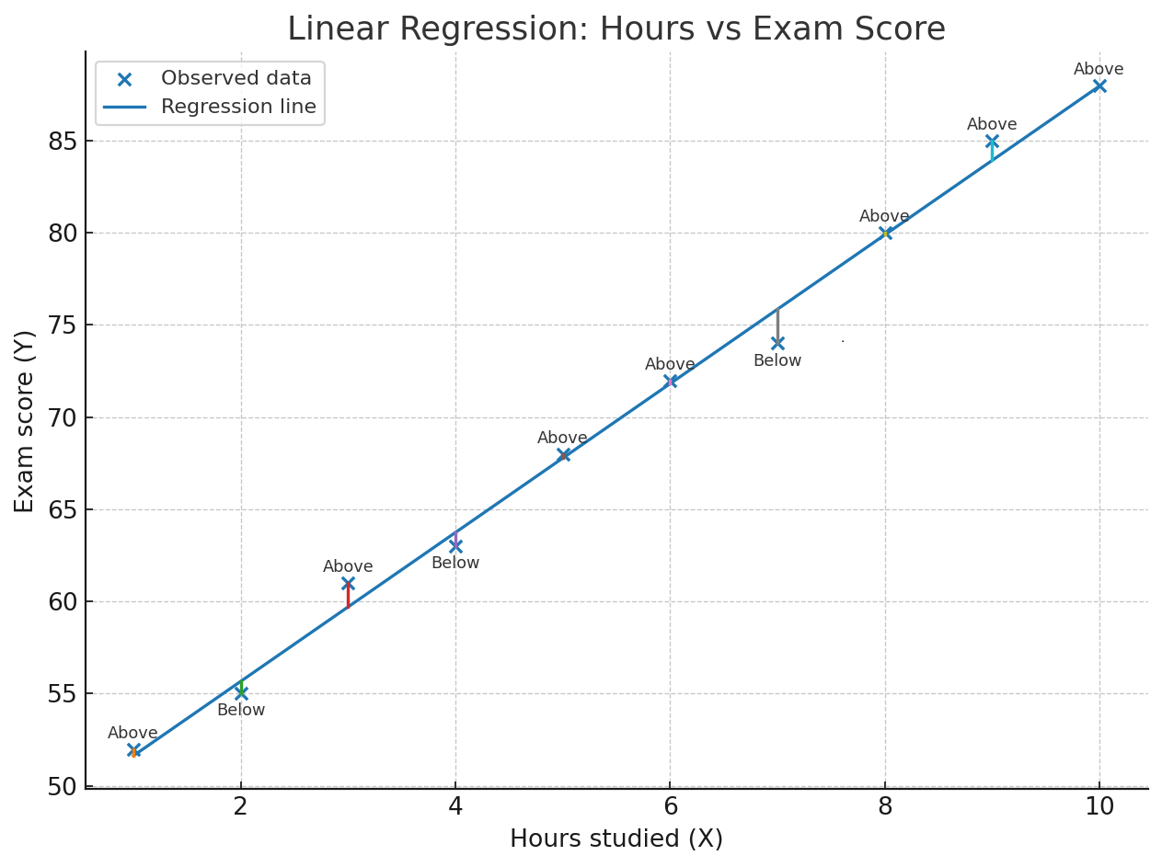
Relation Between Points and Line
- If a point falls exactly on the line, the prediction is perfect (no error).
- If a point is above the line, the actual value is greater than predicted.
- If a point is below the line, the actual value is smaller than predicted.
- The vertical gap between a point and the line is called the residual (error).
Logistic Regression
Logistic regression is a statistical and machine learning technique used for classification problems, not regression (despite the name).
It predicts the probability of an input belonging to a particular class (e.g., "disease" vs. "no disease"). Instead of giving a continuous value like linear regression, it outputs values between 0 and 1, which are interpreted as probabilities.
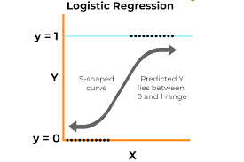
Types of Logistic Regression
Binary Logistic Regression → Two outcomes (e.g., spam / not spam).
Multinomial Logistic Regression → More than two outcomes (e.g., predicting which disease type).
Ordinal Logistic Regression → Ordered outcomes (e.g., rating scale: poor, average, good).
Feature | Linear Regression | Logistic Regression
Output | Continuous value | Probability (0–1)
Used for | Prediction of numerical values | Classification
Function | Straight line | Sigmoid (S-curve)
Example | Predict house price | Predict disease presence

Confusion Matrix
A confusion matrix is a table used to evaluate the performance of a classification model. It summarizes the number of correct and incorrect predictions made by the model, categorized by class.
 | Predicted Positive | Predicted Negative
Actual Positive | True Positive (TP) | False Negative (FN)
Actual Negative | False Positive (FP) | True Negative (TN)

Here we are choosing Cat as positive class and Dog as Negative class
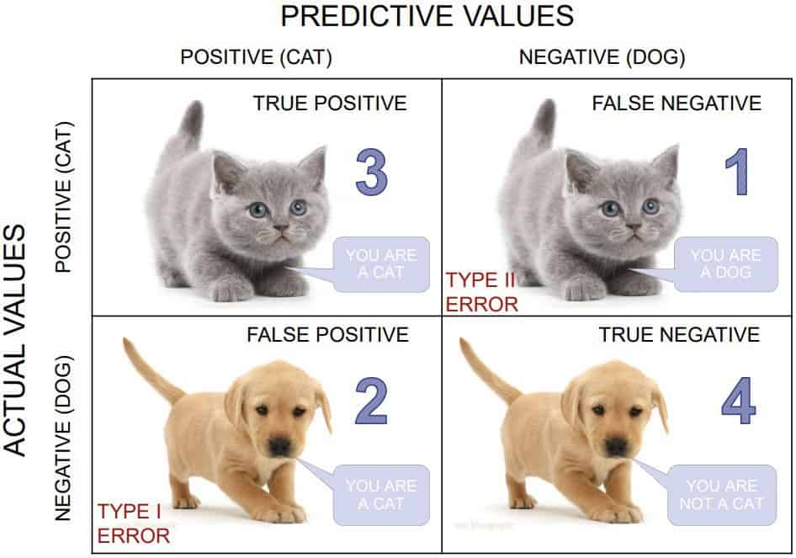
We have a total of 10 cats and dogs and our model predicts whether it is a cat or not.
Actual values = [‘dog’, ‘cat’, ‘dog’, ‘cat’, ‘dog’, ‘dog’, ‘cat’, ‘dog’, ‘cat’, ‘dog’]
Predicted values = [‘dog’, ‘dog’, ‘dog’, ‘cat’, ‘dog’, ‘dog’, ‘cat’, ‘cat’, ‘cat’, ‘cat’]
True Positive: You predicted positive and it’s true. You predicted that an animal is a cat and it actually is.
True Negative: You predicted negative and it’s true. You predicted that animal is not a cat and it actually is not (it’s a dog).
False Positive (Type 1 Error): You predicted positive and it’s false. You predicted that animal is a cat but it actually is not (it’s a dog).
False Negative (Type 2 Error): You predicted negative and it’s false. You predicted that animal is not a cat but it actually is.

Classification Accuracy:
Classification Accuracy is given by the relation:
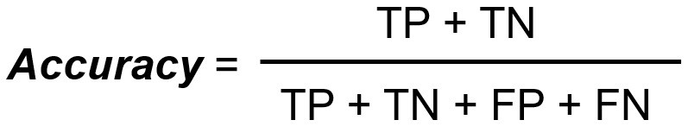
Recall (aka Sensitivity):
Recall is defined as the ratio of the total number of correctly classified positive classes divide by the total number of positive classes. Or, out of all the positive classes, how much we have predicted correctly. Recall should be high.
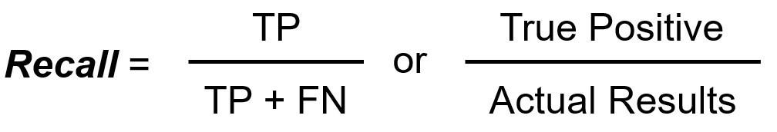
Precision:
Precision is defined as the ratio of the total number of correctly classified positive classes divided by the total number of predicted positive classes. Or, out of all the predictive positive classes, how much we predicted correctly. Precision should be high.
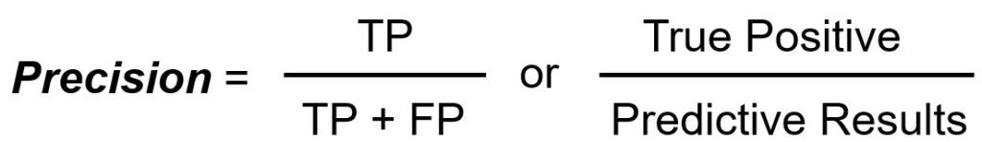
F-score or F1-score:
It is difficult to compare two models with different Precision and Recall. So to make them comparable, we use F-Score. F-score should be high.
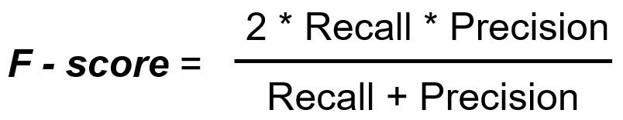

A hospital is testing a machine learning model to detect diabetic foot ulcers (DFU). The test dataset contains 50 patients:
- 25 patients actually have DFU.
- 25 patients do not have DFU.
The model’s predictions are as follows:
- It correctly identified 20 patients with DFU.
- It missed 5 patients who actually had DFU.
- It wrongly predicted 4 healthy patients as having DFU.
- The rest were correctly identified as healthy.
Polynomial Regression
The word comes from math:
- Poly = many
- Nomial = terms
So a polynomial is just an equation made up of many terms involving powers of a variable.
Polynomial regression is just like linear regression, but with a twist.
- In linear regression, we try to fit a straight line to the data (like y=a+bx)
- But sometimes the data does not follow a straight line as it may curve upward, downward, or have more bends.
- Polynomial regression allows the line to bend by adding powers of x:
y=a+b₁x+b₂x²+b₃x³+⋯+b_{n}x^{n}
If degree = 1, the highest power of x is x¹ → this is just a straight line (linear regression).
If degree = 2, the highest power is x² → gives a parabola-shaped curve.
If degree = 3, the highest power is x³ → gives an S-shaped curve with more flexibility.
If degree = 4 or higher, the curve can bend more times to fit the data.
So instead of only a straight line, we can get a curve (parabola, cubic curve, etc.) that fits the data better.
Example in simple terms:
Imagine you are measuring how a child’s height changes with age. In the early years, height grows quickly, then slows down, and later almost stops. A straight line (linear regression) won’t capture this pattern well. But a polynomial curve (say quadratic or cubic) can bend and better follow the actual growth trend.
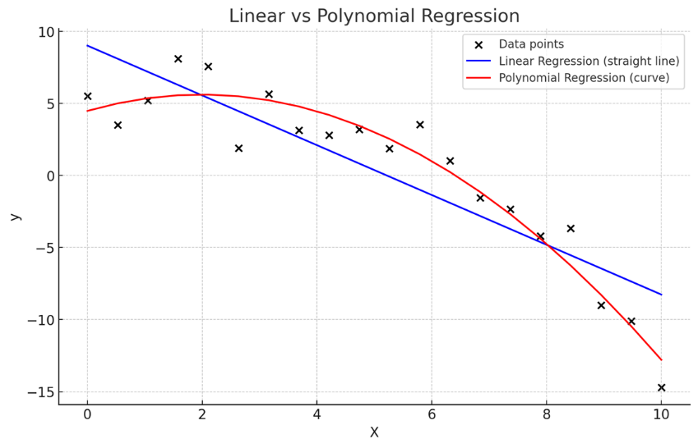
Here’s a simple visual:
- Black dots = actual data points
- Blue line = linear regression (straight line)
- Red curve = polynomial regression (curved line)
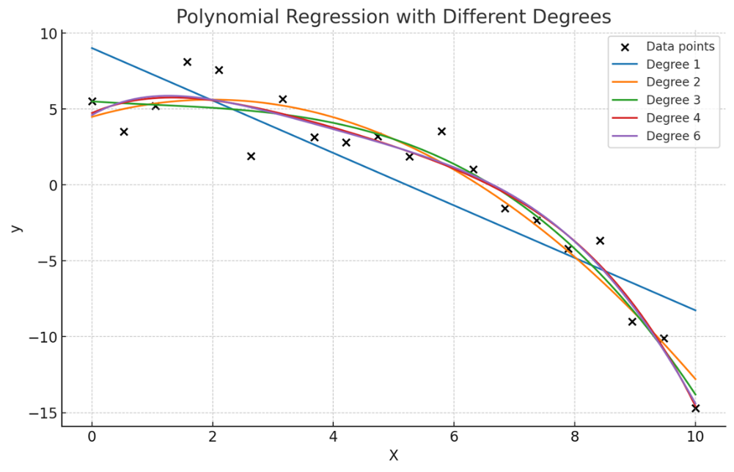
Here you can see how the regression curve changes with different polynomial degrees:
- Degree 1 (blue) → just a straight line (normal linear regression).
- Degree 2 (orange) → parabola (U-shaped curve).
- Degree 3 (green) → curve with one bend.
- Degree 4 (red) → more flexible curves that can bend multiple times to follow the data closely.

